TRC3500 Use of AI Disclosure Form

In TRC3500, you may use any AI tools at your disposal, in any capacity, to complete the assigned work. However, you must disclose which tools you used and how. Generative AI produces feedback or content that may be incorrect or inappropriate. You are fully responsible for the state of work that you submit.

Instructions

* An AI disclosure form must be submitted for the group with every report. Appendix and example need not be included.
* Address every task category listed in the form
* Add tasks if you feel you did something that doesn’t fit in any category but warrants disclosure
* All uses (“Y”) must indicate what tool you used and for what purpose
* See explanations of the categories in the appendix

| Task | N | Y | If Y, specify tool and scope |
| --- | --- | --- | --- |
| Coding: algorithms | X |  |  |
| Coding: syntax assistance | X |  |  |
| Coding: debugging |  | Y | GPT-4o was used to debug the machine learning code |
| Coding: refactoring | X |  |  |
| Coding: documentation | X |  |  |
| Writing | X |  |  |
| Reviewing text | X |  |  |
| Brainstorming | X |  |  |
| Image generation | X |  |  |



Table of Contents

1.0 Introduction 4

2.0 Electrical Circuit Design 4

3.0 Methodology and Testing 5

4.0 Demonstration Performance Evaluation 7

5.0 Conclusion 8

## 

## 1.0 Introduction

This report outlines the design, calibration, and performance evaluation of a compact and low-cost pin-drop detection system developed to complement security systems. The detection system is integrated with a piezoelectric sensor and an STM32 microcontroller to provide real-time vibration readings as serial ADC outputs, as well as a high-pass filter and an op-amp to reduce noise and amplify the desired signals. The system should be able to detect sudden mechanical vibrations and classify the drops of two objects, a coin and an eraser, at four different heights and distances from the sensor each.

## 2.0 Electrical Circuit Design

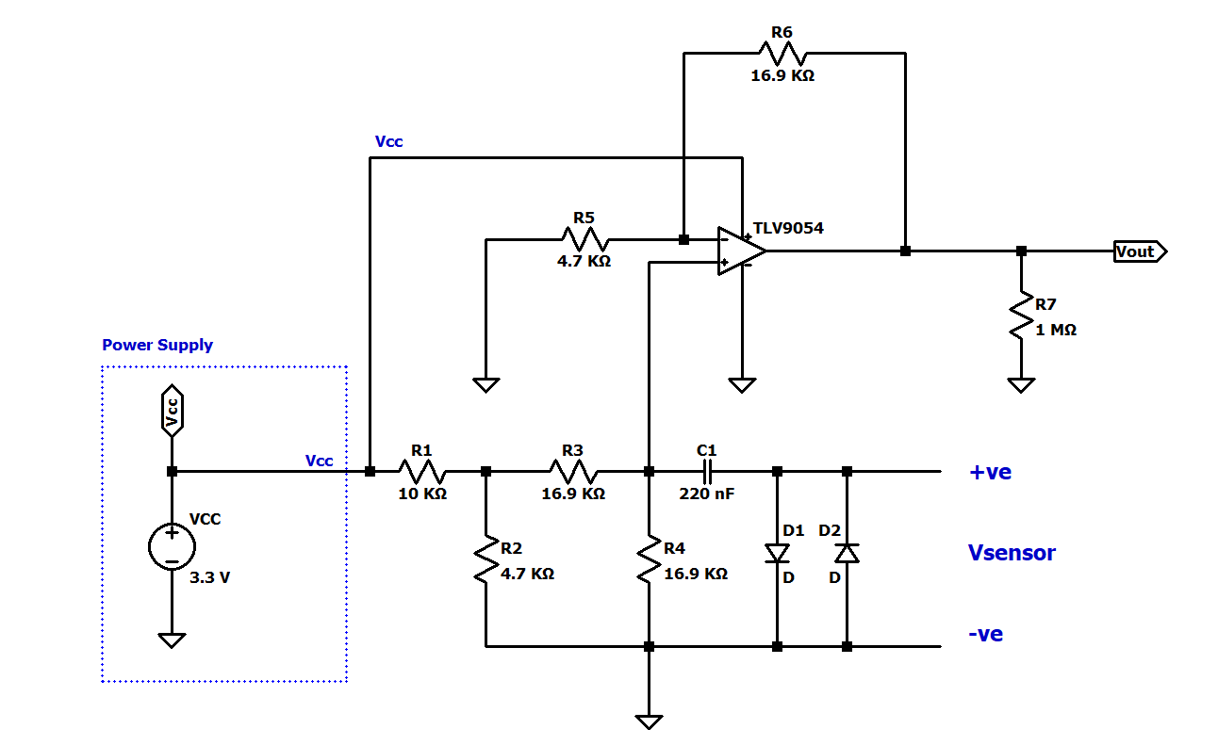

*Fig 1. Schematic diagram of calibration and signal conditioning circuit*

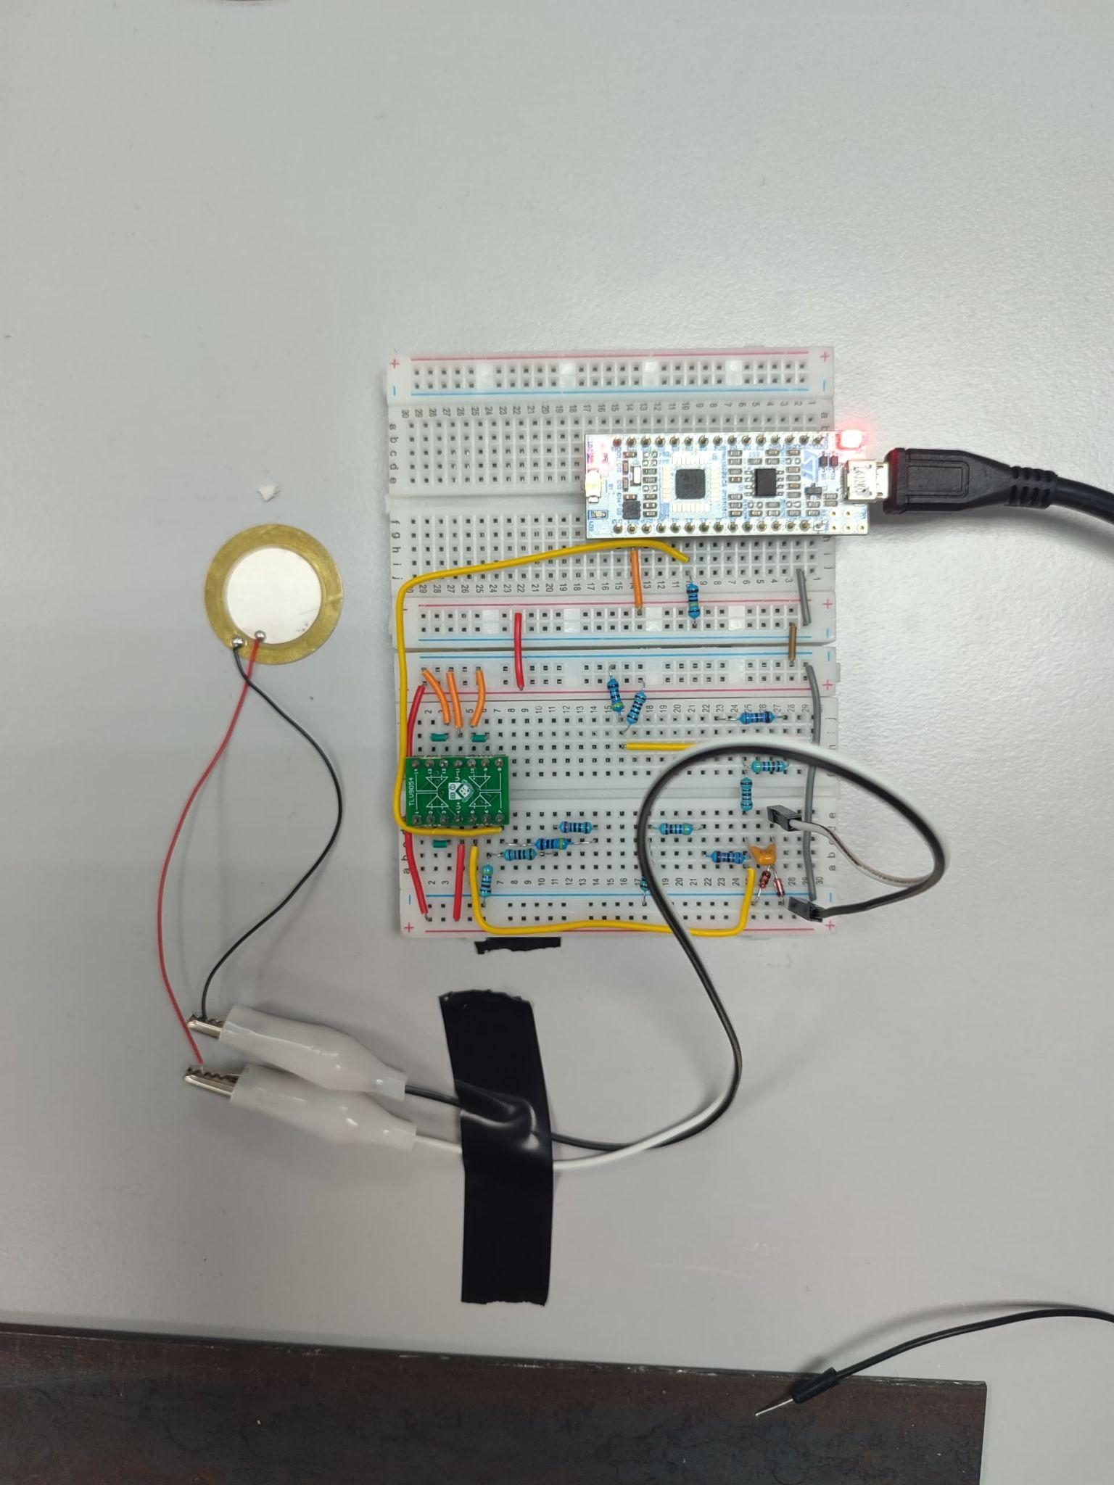 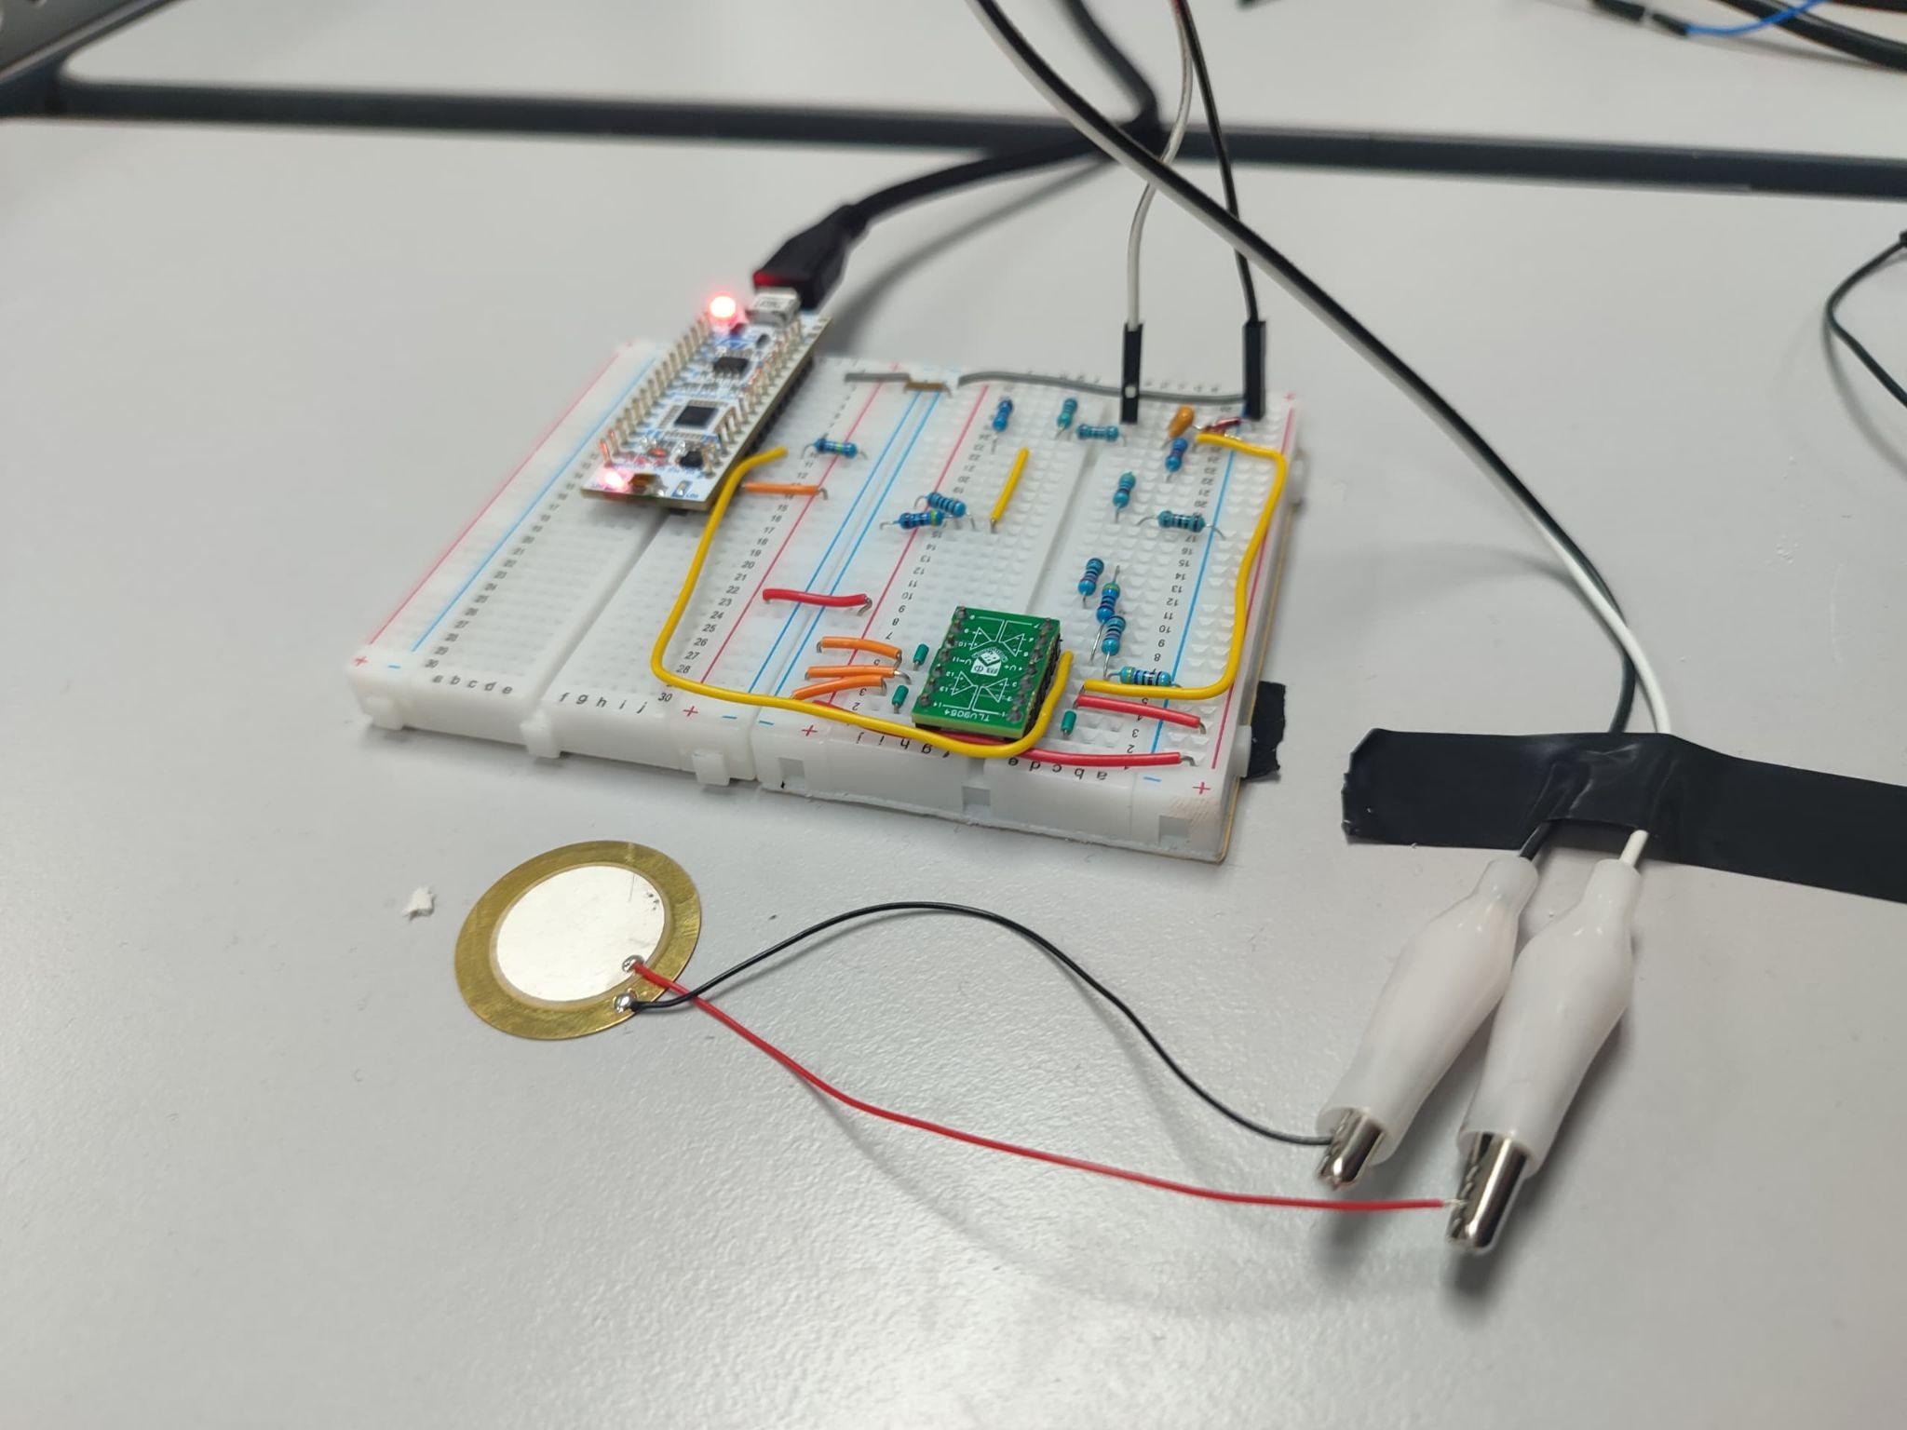

*Fig 2. Top view and side view of the detection system*

The electrical schematics and circuit are shown in Fig. 1 and 2. A piezoelectric sensor is used for vibration detection and connected to a high-pass filter consisting of **C1** and **R4** to remove background noise at a frequency of over **42 Hz**. After this, a voltage divider circuit is used with resistances of **10 kΩ** and **4.7 kΩ** to reduce the voltage to a constant **1.1V** as input for the bias. 3.3V is connected to the supply of TLV9054 to act as a non-inverting op amp and amplifies the desired signals from the sensor by a **gain = ~3.6**. The amplified signal is grounded by a **1 MΩ** resistor to remove any noise and sent to the STM32 microcontroller, which communicates with a Python interface through serial UART communication. As the sensor can produce a voltage high enough to damage the STM32, it is protected with diodes.

Since the piezoelectric sensor outputs an AC signal that ranges from **-3.3V** to **3.3V**, the STM32 can only process the positive half AC signal without a bias, which will affect the quality of the collected data. Hence, a **1.8V** bias is added using **R3** and **R4** to shift the sensor signal to the readable range of **0V** to **3.3V,** allowing both positive and negative signals from the sensor to be captured for accurate analysis of frequency, zero-crossing, and energy.

## 3.0 Methodology and Testing

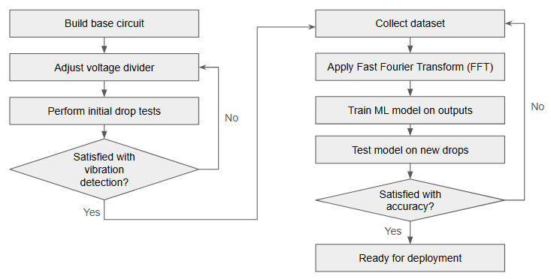

*Fig 3. Detection system calibration and testing flow chart*

The detection system was tested with a rigid and dense object—a fifty-cent Malaysian coin—and a soft and light object—an eraser—at varying heights and distances from the piezoelectric sensor. The heights and distances used were combinations of 10 cm and 30 cm, totalling 4 classes for each object and 8 in total. These values were chosen as they were distinct from each other, yet close enough to the sensor to produce reliable and consistent outputs.

The coins and erasers were dropped into either a 10cm or 30cm tall well to ensure they landed in the same area each time, and always dropped from the same position and orientation with the largest surface area facing the bottom. As outlined in Fig. 3, the circuit’s voltage divider had its resistance values altered to find the best value for consistent vibration detection. Vibration detection was monitored and measured through the Python interface and an oscilloscope.

The Python interface is always waiting for a vibration at a threshold slightly above the resting voltage. When this is triggered, it will capture the vibrations at a 10kHz sampling rate for 0.2 seconds and perform digital signal processing by removing outlier values and applying a Fast Fourier Transform (FFT).

Once satisfied with the vibration detection and achieving strong performance for all tested classes, machine learning with a Multi-Layer Perceptron (MLP) was utilised to classify the vibration data more easily as it was not linear and difficult for the human eye to interpret. A dataset with 150 samples for each class of data was collected, totalling 1200 datasets across the 8 classes. This number was chosen as it was achievable to collect new datasets when required, yet it was large enough to train a good model on. The outputs of FFT, such as peak amplitude, energy, duration and zero crossings, were used as the input features for training.

After training and testing on new data, the coin achieved strong performance, as it was consistently detectable regardless of distance or height up to 100 cm away from the sensor. The eraser showcased a weak performance at 10cm height drops further than 30cm away. Non-performance was observed when testing with materials softer and lighter than the eraser, like foam or tissues, at all heights and distances past 5 cm from the sensor. The confusion matrix, accuracy, and positive predictive value (PPV) for detection across 80 drops per object are shown in Fig. 4 and Table 1.

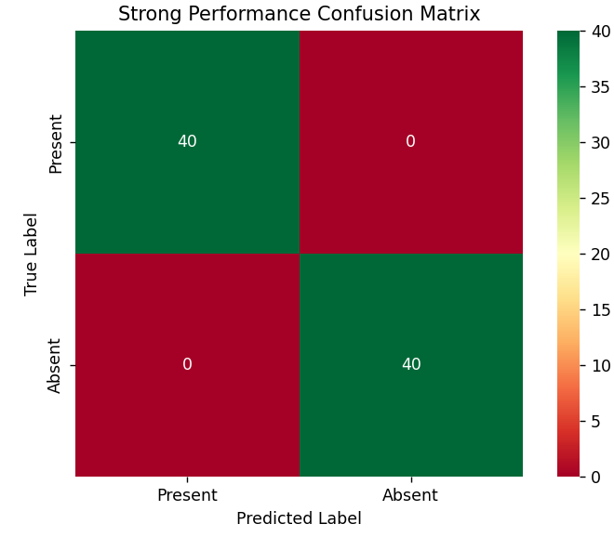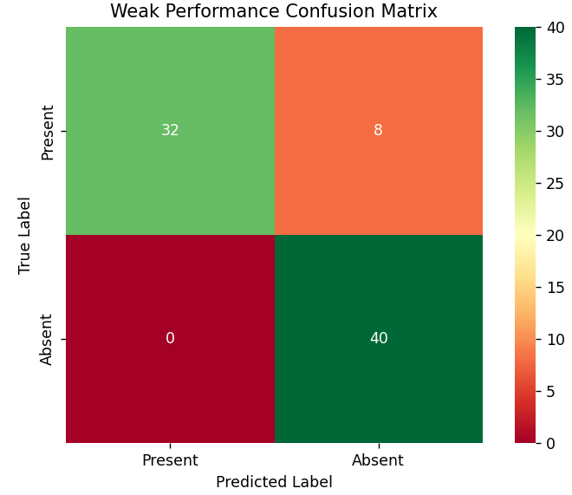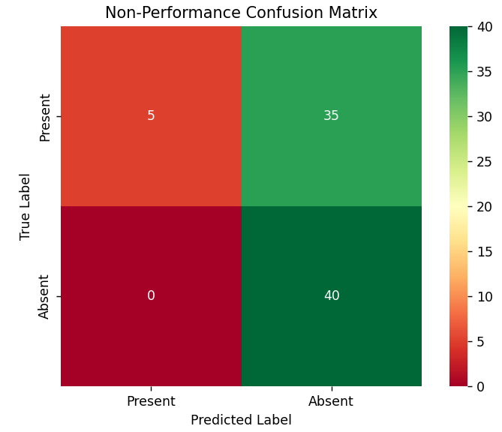

*Fig 4. Confusion matrix for different levels of performance*

*Table 1. Accuracy and PPV for different levels of performance*

|  | Strong performance | Weak performance | Non-performance |
| --- | --- | --- | --- |
| Accuracy | 1.00 | 0.90 | 0.56 |
| PPV for Present | 1.00 | 1.00 | 1.00 |
| PPV for Absent | 1.00 | 0.83 | 0.53 |

A classification confusion matrix was also produced for the best MLP model, as shown in Fig. 5 and Table 2. 30 trials were done for each class, which is 20% of the initial data taken for training and was settled upon as a dataset large enough to evaluate accuracy reliably, yet not too large to conduct repeated trials. Most of the errors are in neighbouring classes, providing confidence that those are merely edge cases and not random guesses. The accuracy rate is 85%.

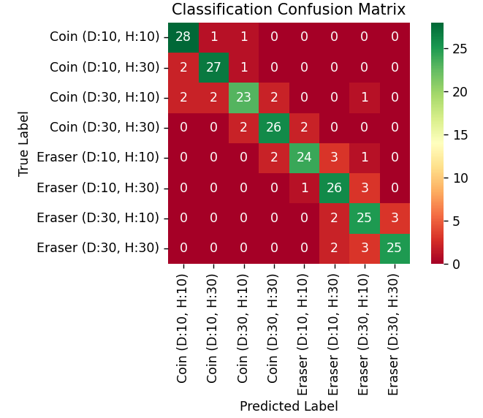

*Fig 5. Confusion matrix for classification within strong performance*

*Table 2. PPV for classification confusion matrix*

|  | Coin (D:10, H:10) | Coin (D:10, H:30) | Coin (D:30, H:10) | Coin (D:30, H:30) | Eraser (D:10, H:10) | Eraser (D:10, H:30) | Eraser (D:30, H:10) | Eraser (D:30, H:30) |
| --- | --- | --- | --- | --- | --- | --- | --- | --- |
| PPV | 0.88 | 0.90 | 0.85 | 0.87 | 0.89 | 0.79 | 0.76 | 0.89 |

## 4.0 Demonstration Performance Evaluation

The live demonstration evaluated the classification accuracy for five trials of each class, during which we achieved an accuracy of merely 35% compared to the previous 85%. There are a few possibilities for the failure to replicate the accuracy and PPV seen in previous tests.

The dataset our best model was trained on was taken and evaluated on new data in a quiet laboratory with minimal people around. There were many more people and thus a higher number of electronic devices present during our demonstration, which provided more sources of interference through coupling with our wires. Our detection system is also quite sensitive and able to detect vibrations from nearby surfaces, which may have interfered with some data captured and thus affected the classification.

In addition to that, our machine learning model was trained on data where the baseline voltage hovered around 1.95V, but the baseline voltage fell to 1.85V before the demonstration. This sudden change is suspected to be due to small power supply variations from the laptop used’s USB port, or perhaps due to the changing of wires from longer jumper wires to flat and cut-to-size wiring having slightly less resistance. The model likely performed differently as the FFT outputs for the drops would have changed slightly, leading to the predictions being slightly off.

This effect could have been minimised with the use of proper shielding and grounding with equipment like guard rings, performing the demonstration in a less busy environment, or training the model on a larger and more varied set of data. However, due to equipment, space, and time limitations, we were not able to implement these methods.

Though the eraser usually showcases weak performance past 30 cm, we were able to successfully detect five drops in a row 180cm away from the sensor due to lowering the threshold voltage needed to trigger event detection to 10 mV above the highest point of noise, though this is too low of a threshold for regular deployment as someone walking next to the table may be able to accidentally trigger an event.

## 

## 5.0 Conclusion

The designed circuit succeeds at being a cost-effective, accurate, and reliable vibration detection system. Through many rounds of testing both the hardware and software aspects, the system was carefully calibrated to be able to capture and classify drop data across 8 classes using FFT and machine learning with an MLP.

The detection system performed quite well with the intended objects, though it demonstrated a weaker performance for the eraser than the coin for distances further than 30cm. Additionally, objects softer and lighter than the eraser showcased non-performance, with only a few drops being detected. The detection system showcased high accuracies and PPVs for classifications within the strong performance range.

Future work can focus on increasing sensitivity to current non-performance data and training a more robust MLP model that can perform in various settings, regardless of the electronic noise and number of people present. Regardless of these considerations, the pin-drop detection system still fulfils the current design objectives laid out and is ready for integration into simple security systems.